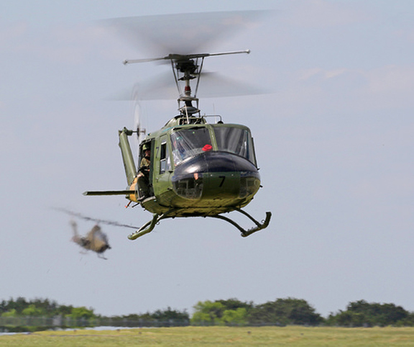
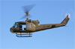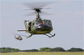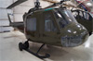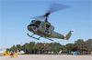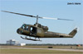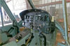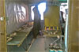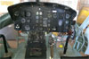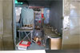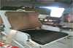
Lycoming T-53-L-13B 2400 TBO
SN LE-14886B
1316 Hours Remaining until OH
Garmin 250XL GPS/ COMM
King KT 76A Transponder
Military Green
Refurbished military interior
Garlick Helicopter STC
Restricted Category
1-859-250-0082
Click to Email:
albert@raptoraviation.com

