Personal Information  Full name: Dean Lynton Warren  Identity no.: 7208315515082  Date of birth: 31 August 1972  Nationality: South African  Marital status: Married  Dependants: Two  Languages: English (Home), Afrikaans (Good),Spanish (Good)  Address: 4C Sheppard Street, Nelspruit, Mpumalanga  Telephone: +27 60 932 1099 (cell)  E-mail: dean@limpopo.co.za | 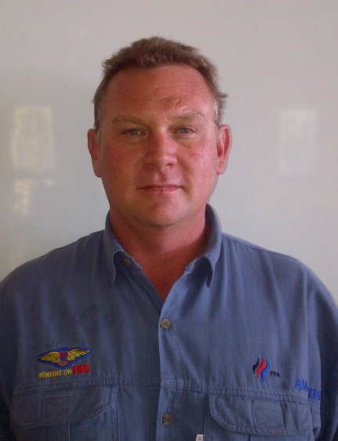

Summary
Senior Aircraft Maintenance Engineer with 11 years’ experience working in a deadline driven environment. Available to start with one months notice. Willing to relocate for the right opportunity. Hard working trustworthy very reliable, meet my deadlines and I am an inspiration to my colleges. I have been head of a helicopter division for 5 years and I am passionate about helicopters. I accept criticism well if it is appropriate. I work well with good competent managers. I am a company person if they look after me and are driven by the same motives.

Skill Summary
Information Technology skills: | Key: 1=Training only, 2=Limited Practical, 3=Solid Practical, 4=Advanced, 5=Expert  Technical Skills  Skill Years Last used Level  Pneumatics 11 current 5  Gearboxes 11 Current 5  Welding 4 Current 2  Brazing 4 Current 2  Milling 6 Current 3  Hydraulics 11 Current 5  Soft skills  Skill Years Last used Level  Team leader 6 Current 4  Supervisor 4 Current 4

Employment History
2015 – 2016 Nicholson helicopters. Maintenance Engineer, Bell 205, Bell 407, Bell 206 series.

2014 – 2015 Helinuigini PNG. Touring work as Lead Maintenance engineer on Bell 205A1,
 | Bell 407, Bell 206 B and L series. BK- 117.
2008 – 2014  2007 – 2008  1998 – 2007 |  |  |  |  | F A Aviation AMO 1116 Pty Ltd  Executive Helicopters  Self Employed |  |  | Aircraft Maintenance Engineer with responsibility of entire  Fleet of firefighting helicopters ranging throughout South  Africa. Scheduled maintenance as well as unscheduled maintenance, field service. Component tracking and replacement when due. Started the AMO with my Manager from the start.  Aircraft Maintenance Engineer  Base & field maintenance on fleet of 7 Bell 205 UH-1H  & Bell 205 A1 helicopters. Hands on experience in  Rebuilding UH-1H Bell 205’s.My experience extended  Into the component and engine shops where I gained  component overhaul time  Own Eco Safari and Hunting outfit in Zimbabwe and  South Africa. Handled all logistics – bookings,  Accommodation, vehicles, professional hunters ,tracker,  skinners and field preparation of trophies. Developed  game farm and built hunting lodges as well as conference  centre

Academic Information
Tertiary |  |  | - Aviation Based
Secondary  1989 |  |  | Grade 12  Florida Park High  - Subjects:  - Maths  - Science  - English  - Afrikaans  - Geography  - Metal Work/ Wood Work  - Technical Drawing

Supplementary Courses / Certifications
Date |  |  |  | Course Completed |  |  | Institution |  | Duration
1990 |  |  |  | National Service/Military Training Advanced (Reaction Force Unit) |  |  |  |  | 3 years
1991 – 1994  1993 – 1994  1995  2008-2013 |  |  |  | Aircraft Maintenance Engineer  Advanced Scuba diving  Diver Rescue Techniques  Professional Hunting and Safari Tourism  Civil Aviation Regulations & Civil Aviation Technical Standards  Rotorcraft General  Airframe General  Gas Turbine General  Piston Engine General  PT-6 Series Engines  Barron 55/58 Series  Pitot Static  Cessna Series  Human Factors |  |  |  |  | 4 years  2 years

Other Interests and Hobbies
Hobbies |  | - Hunting
Other |  | - Fishing, Diving

References
Ian Nicholson
Nicholson Helicopters
082 5525839
Emile Grobler
FFA Aviation- AMO
Tel: +27 (013) 741 8222
Cell: +27 (0) 82 926 9231

